PhysioNET: <https://archive.physionet.org/cgi-bin/atm/ATM>

Dosya Adı: samples.csv

Kaggle: <https://www.kaggle.com/code/ssunssai/prediction-emotion-from-eeg-signal/data>

Dosya Adı: emotions.csv

Kaggle:<https://www.kaggle.com/datasets/sam1o1/eeg-dataset-collected-from-students-using-vr/discussion>

Dosya Adı: EEG_Dataset

Ve içindeki

Subject00_0.csv

Subject01_1.csv

Subject02_0.csv

Subject03_1.csv

Subject04_0.csv

İşlem yapıldı.

**1.PROJE**

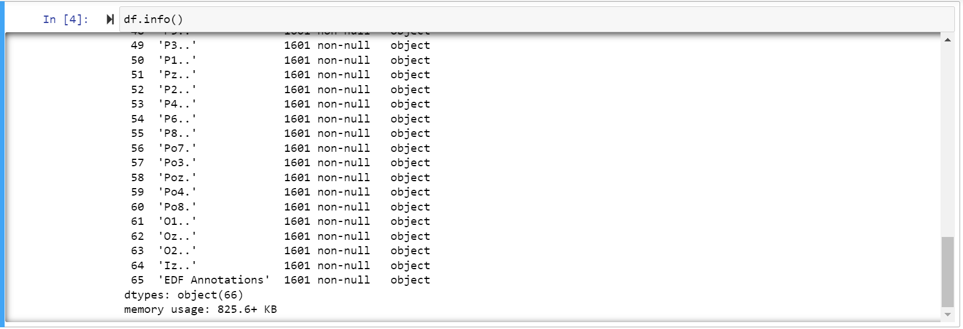

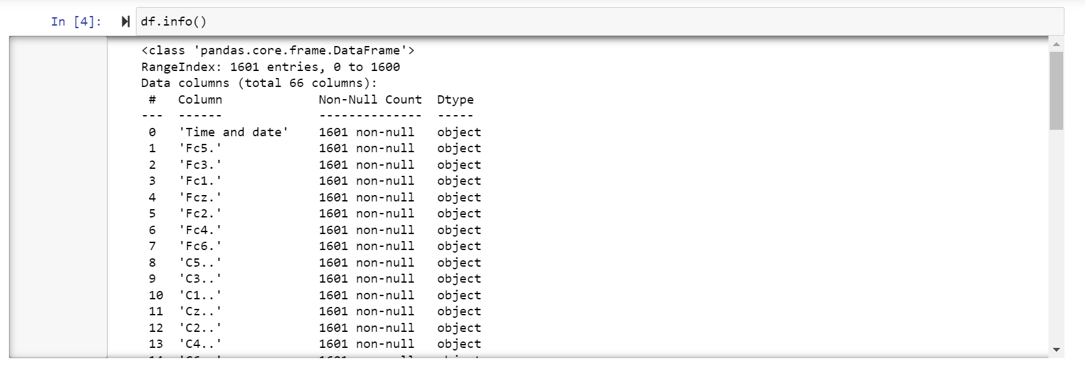

**2.RPOJE**

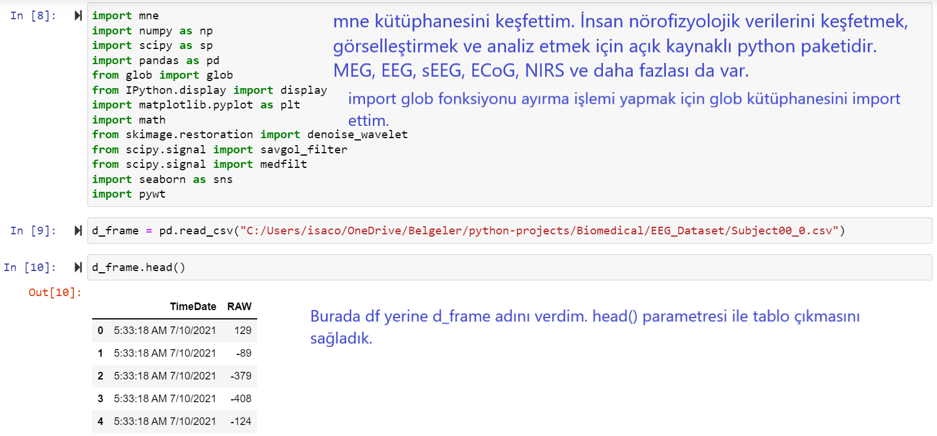

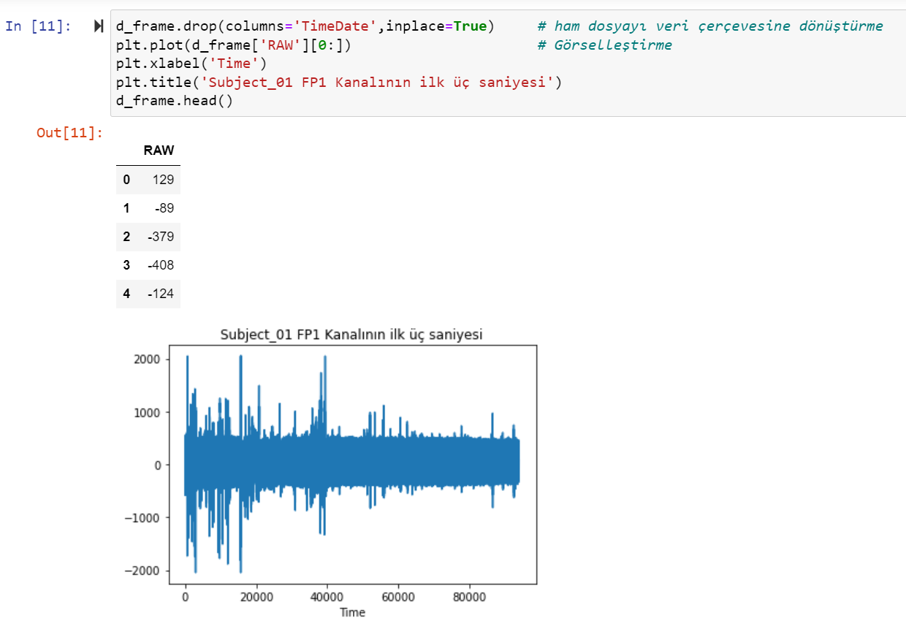

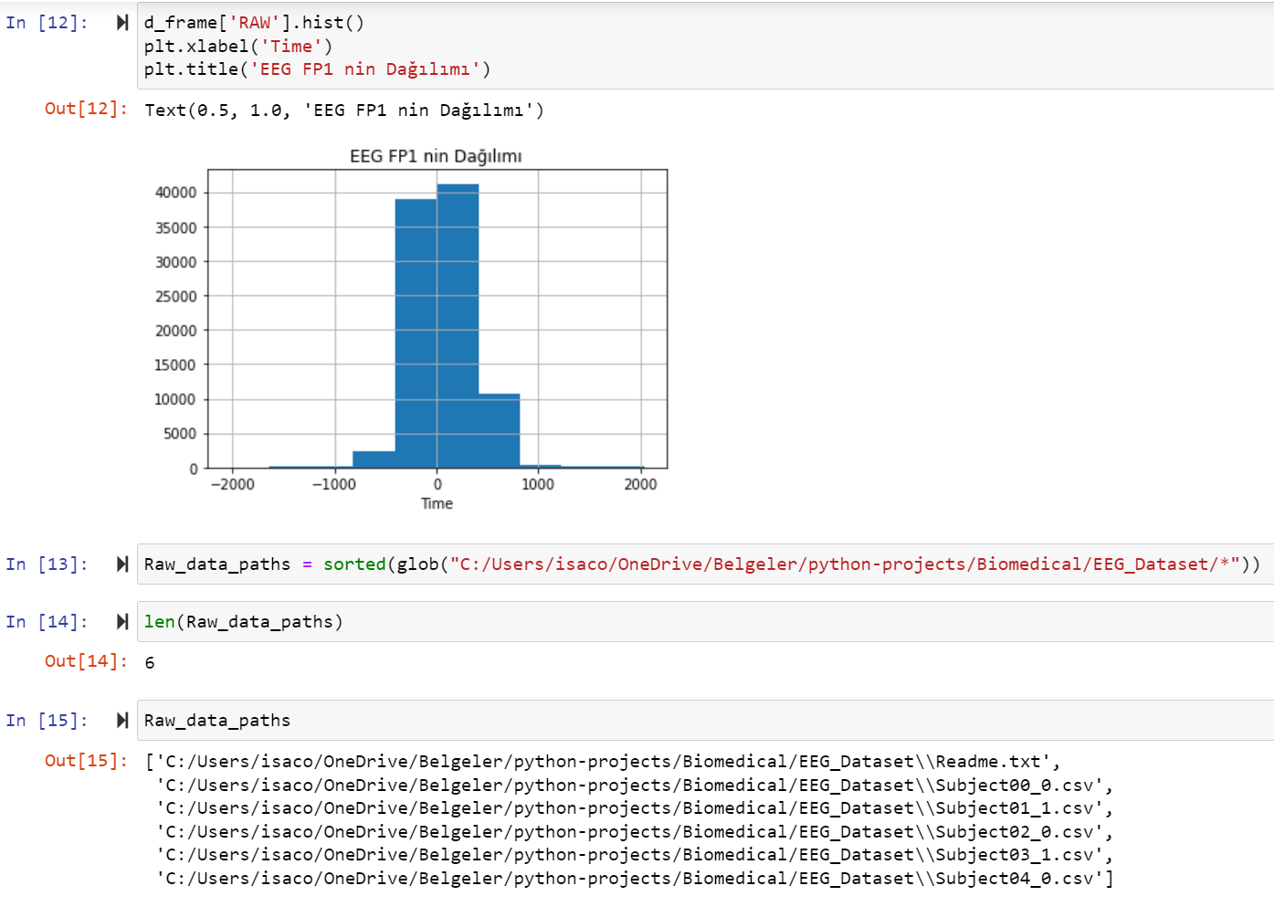

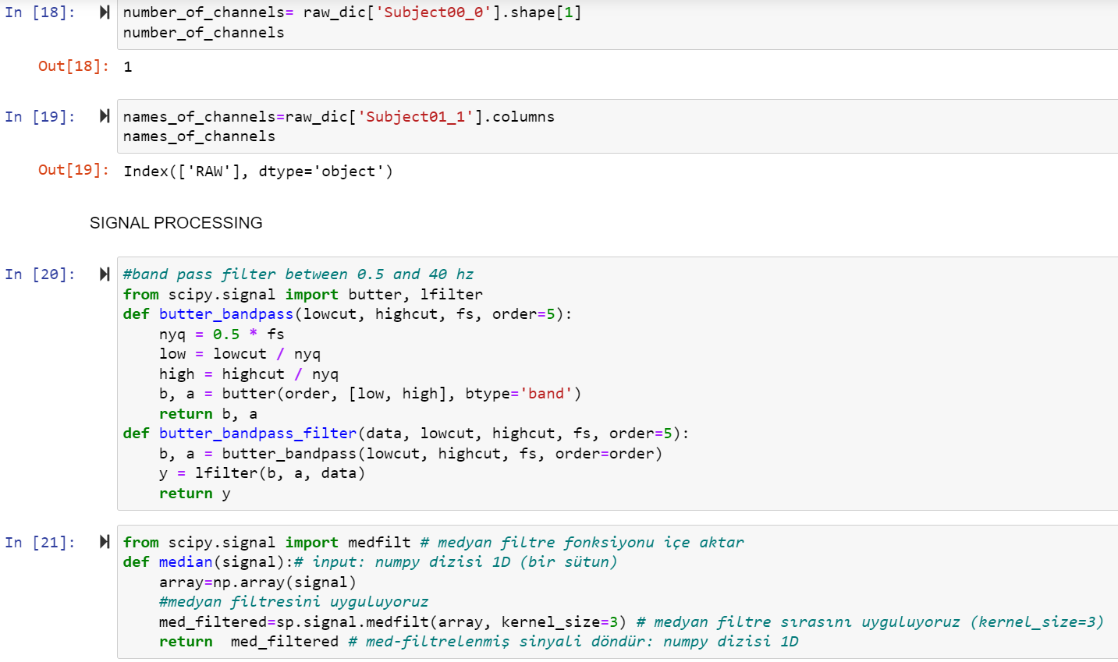

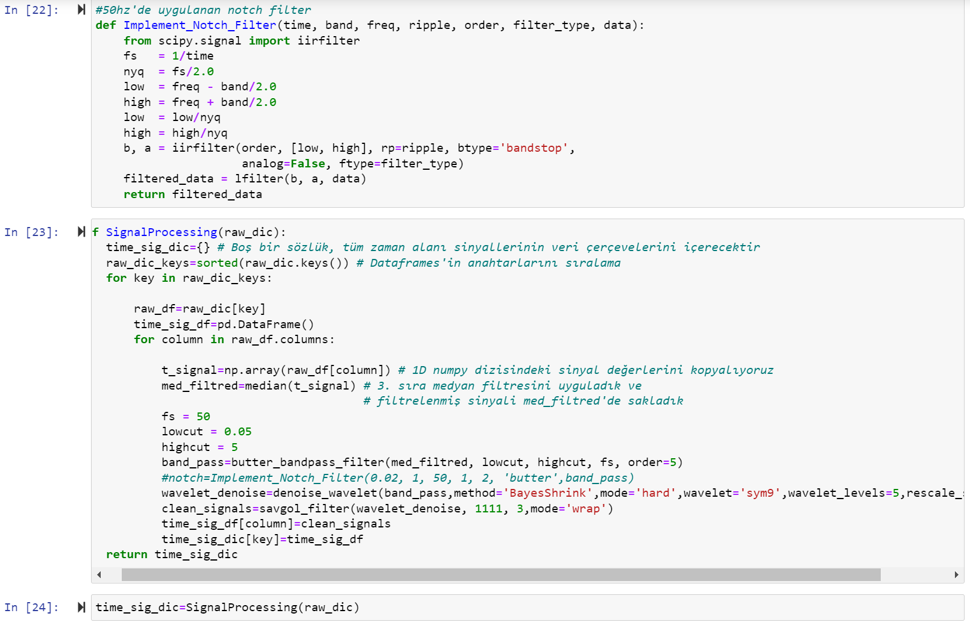

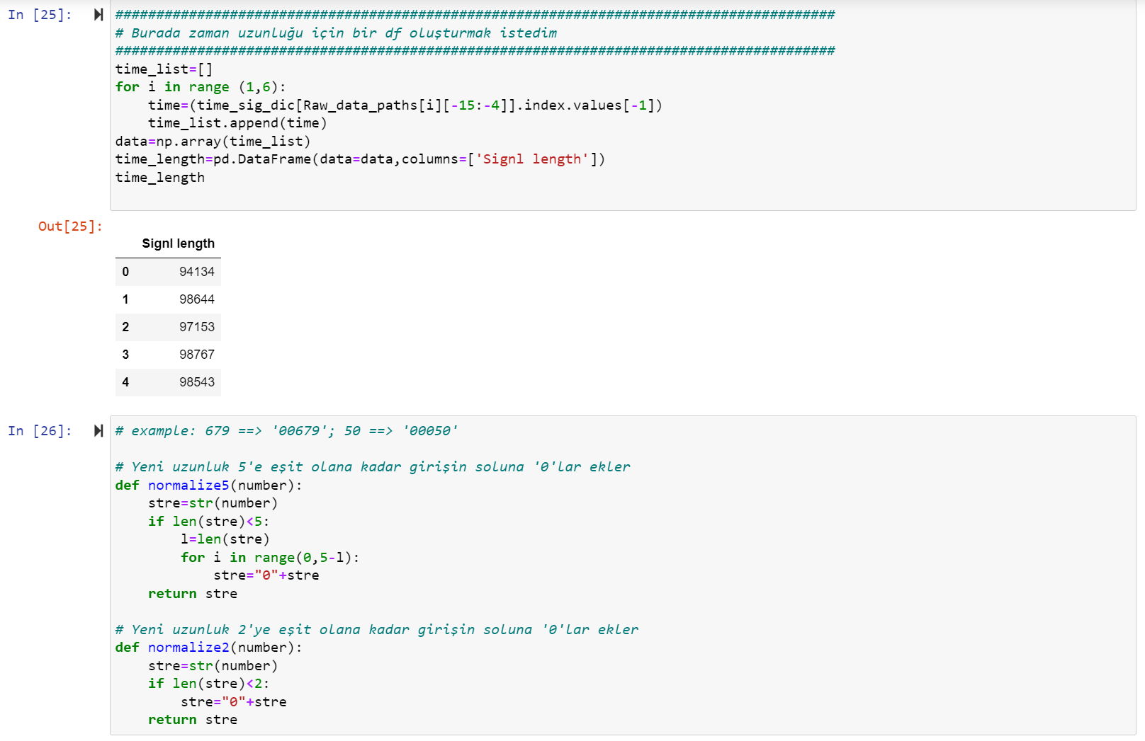

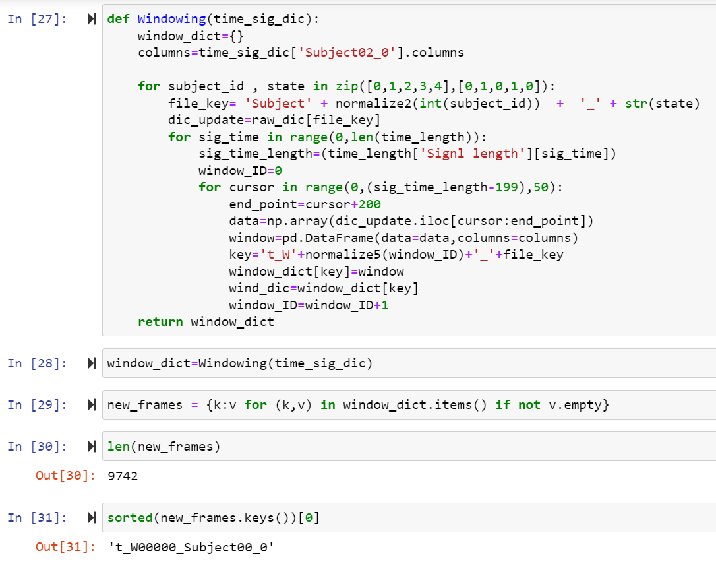

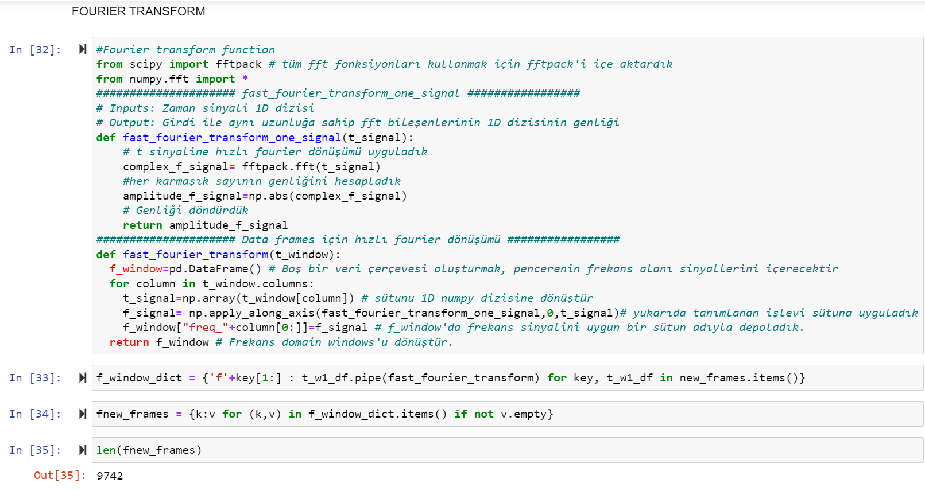

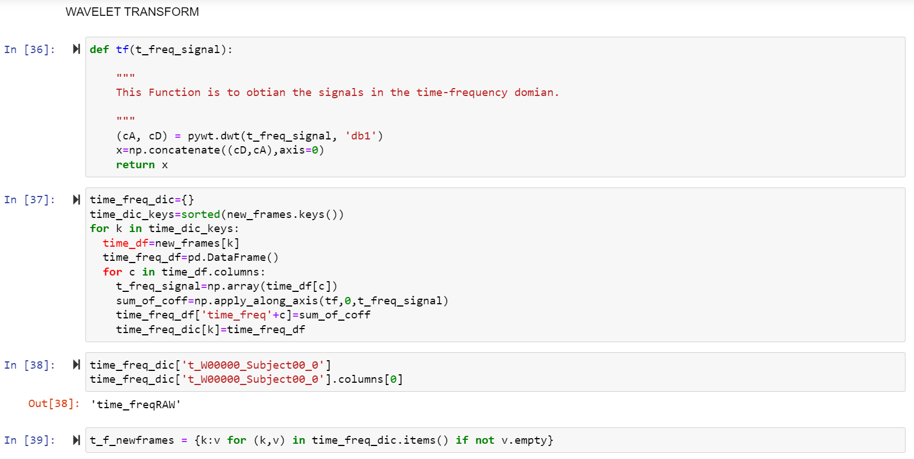

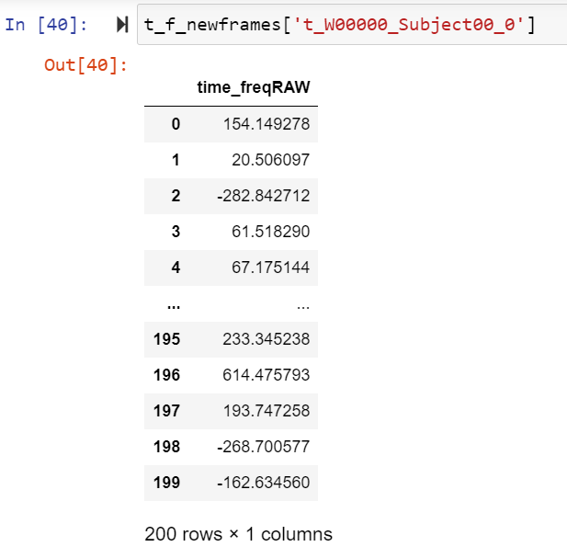

**3.PROJE**

